LAB Logbook

Lab 1
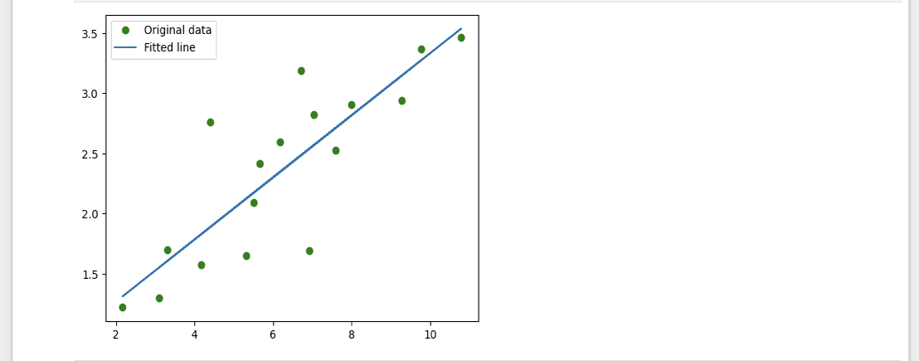
Lab 2
- Accuracy – “0.948”
- MLP architectures
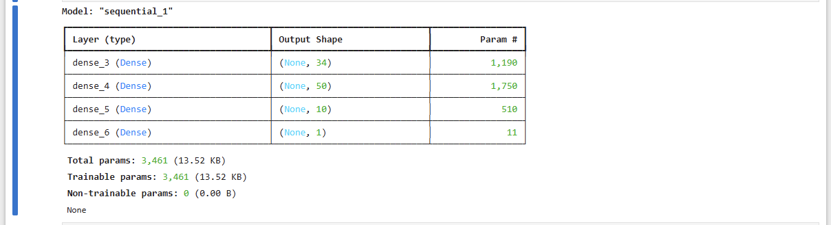
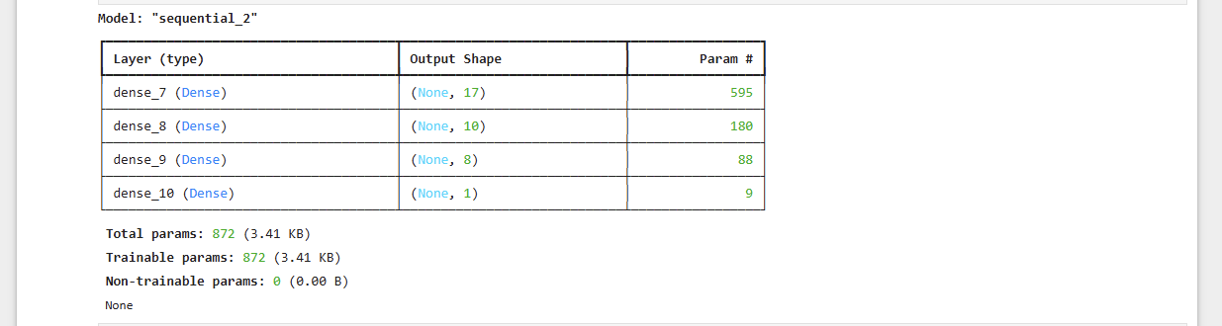3.The output of the neural network as provided in Task 2 is – “0.733”

Lab 3
Accuracy – “0.8859000205993652”

model.summary()

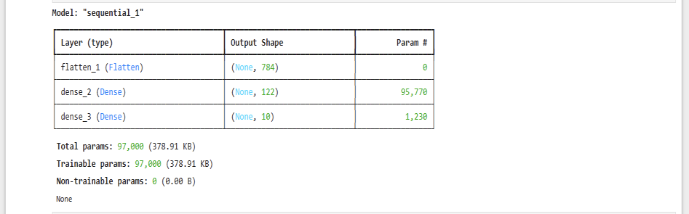
Lab 4
The model's loss after every epoch:
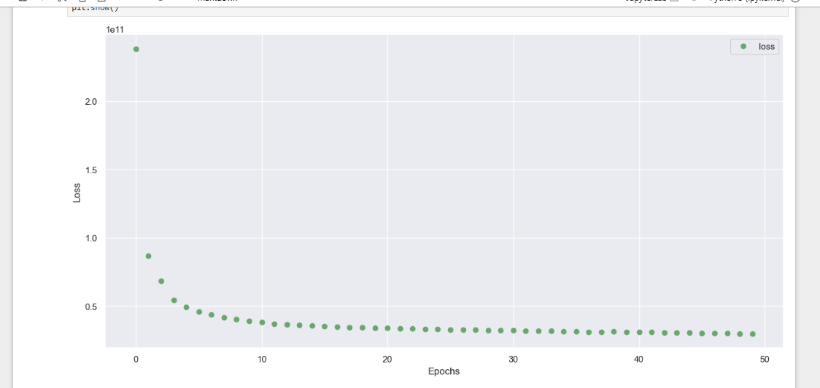
Model Summary:

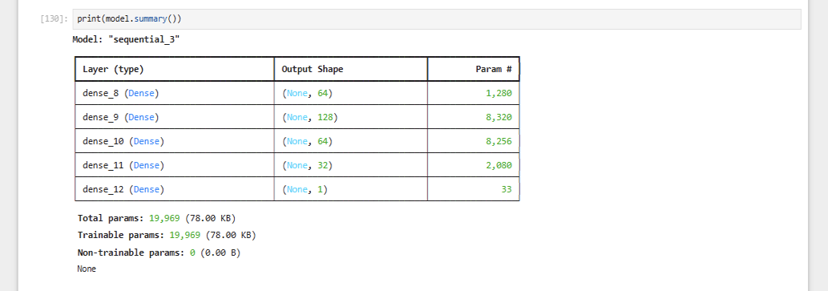
Lab 5
Model Summary:
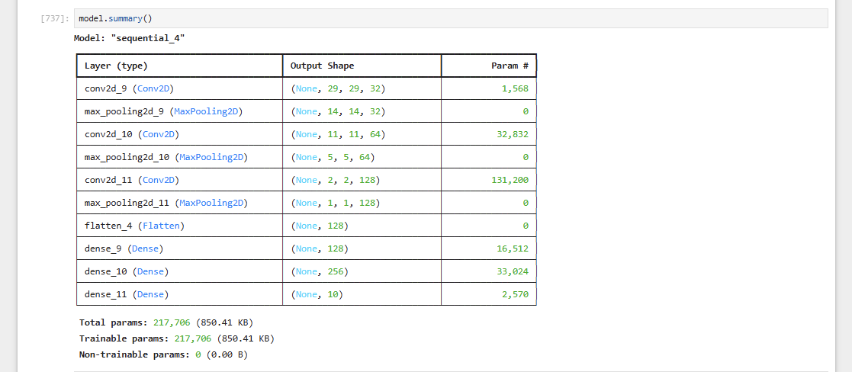
The train loss and validation loss trends
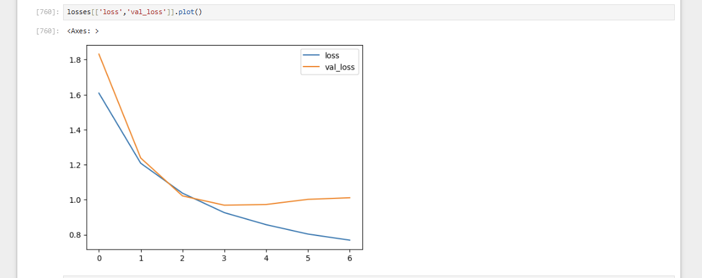The optimal number of epochs for training your model:
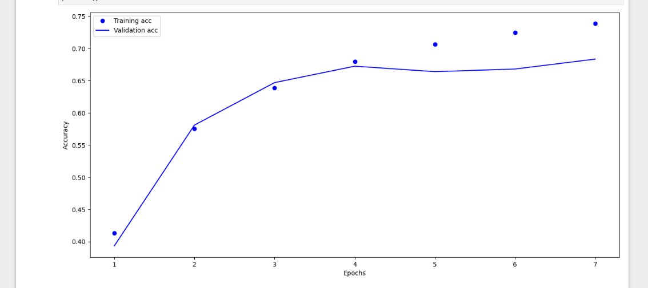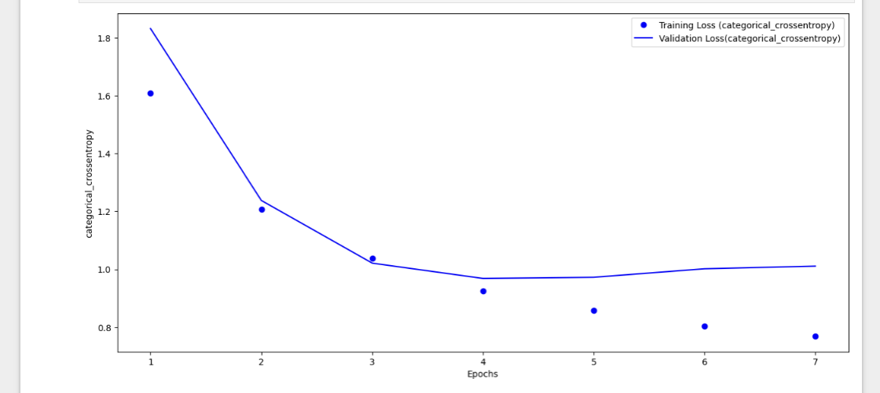
Lab 6
1.Model Summary:
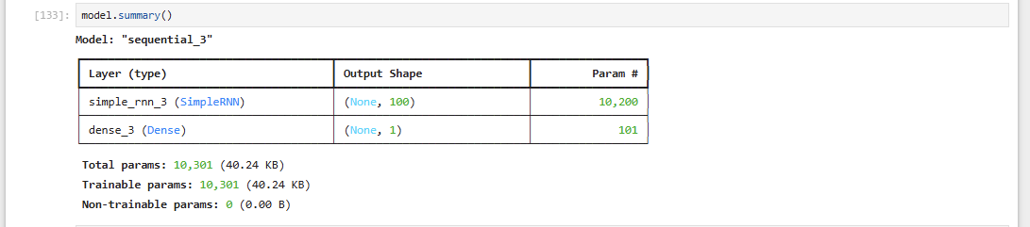

2.early-stop code and history_2 fit-training-process:
early_stop = EarlyStopping(mo nitor='val_loss',patience=2)
history_2 = model.fit(generator, epochs=30,
validation_data=validation_generator,
callbacks=[early_stop])

3. The plot of validation and test loss of history_2:
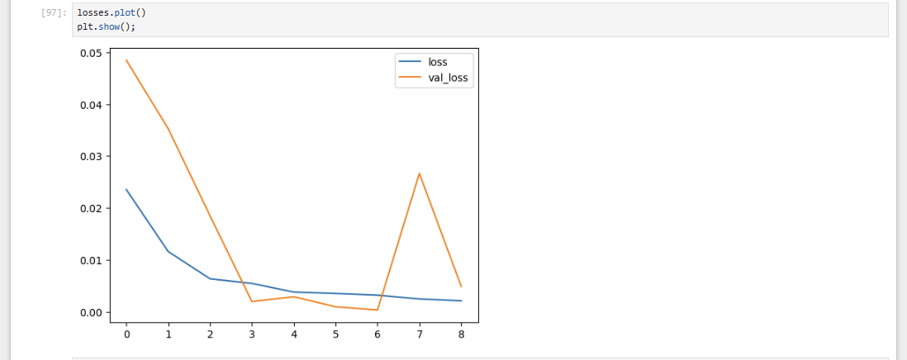4.determine the optimal number of epochs for training your model:

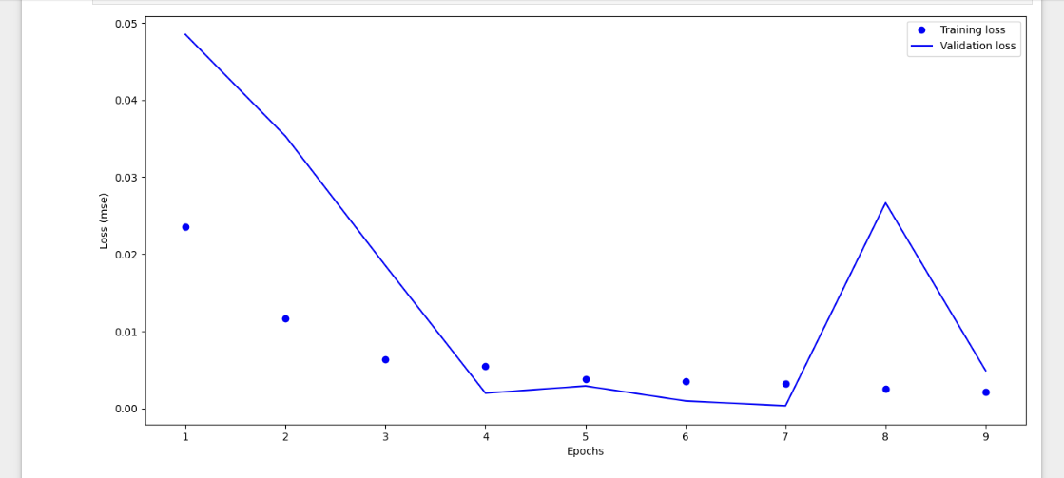

Lab 7
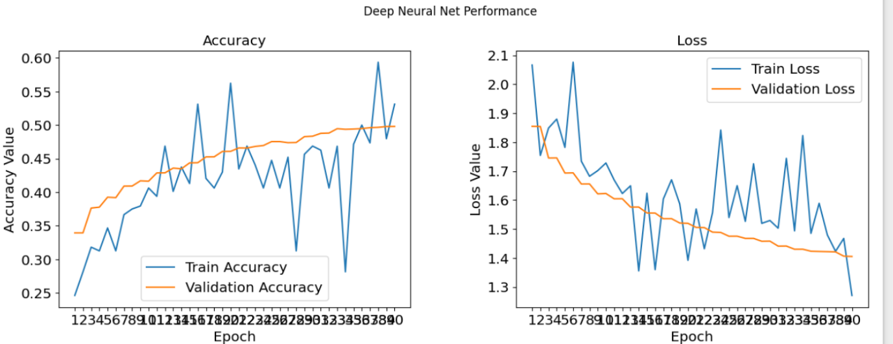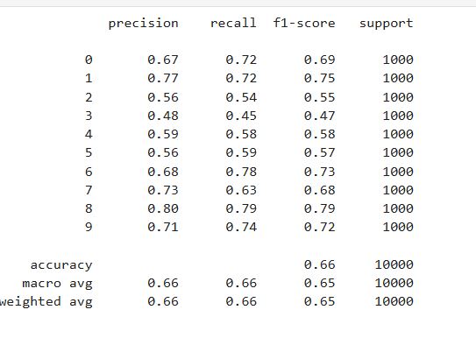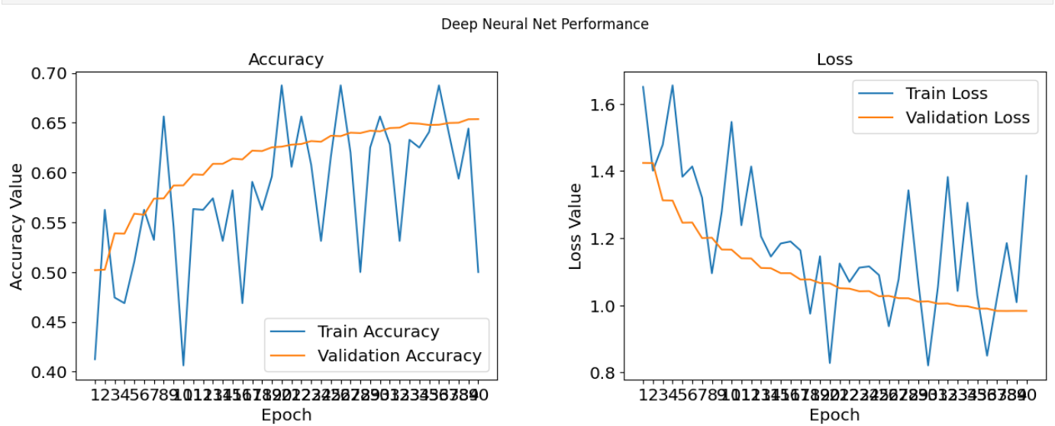
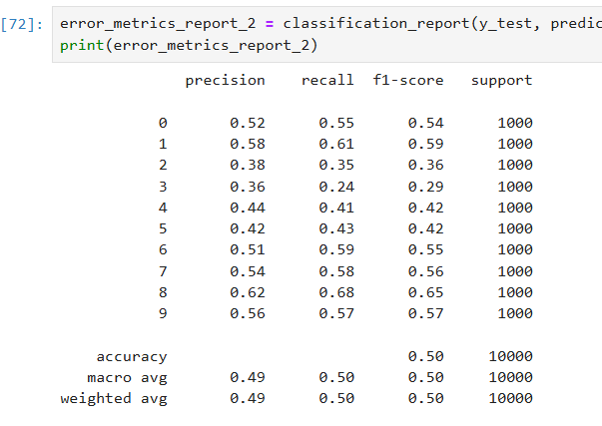
Lab 8
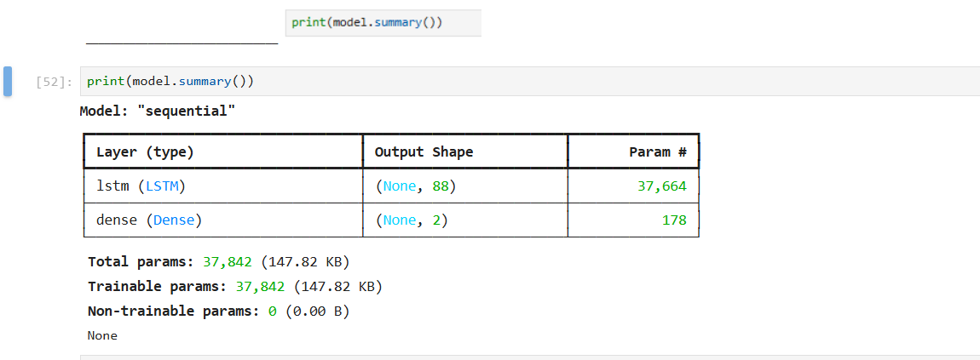
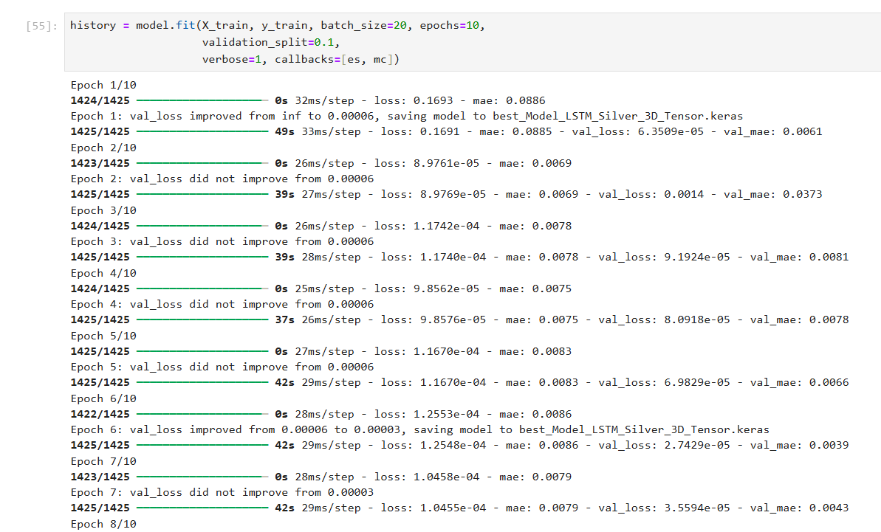
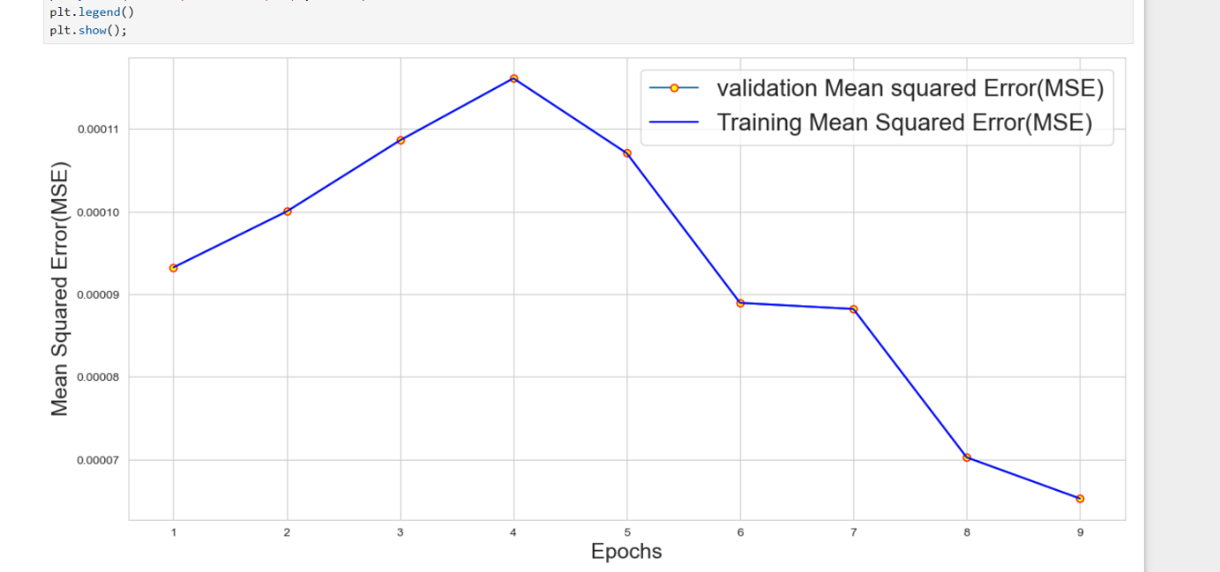
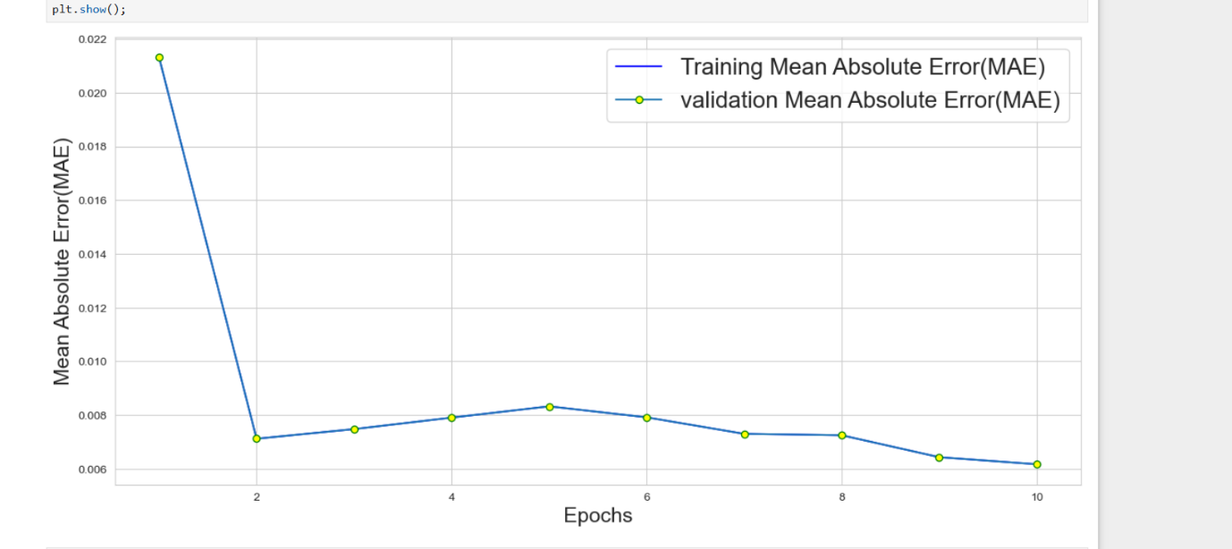
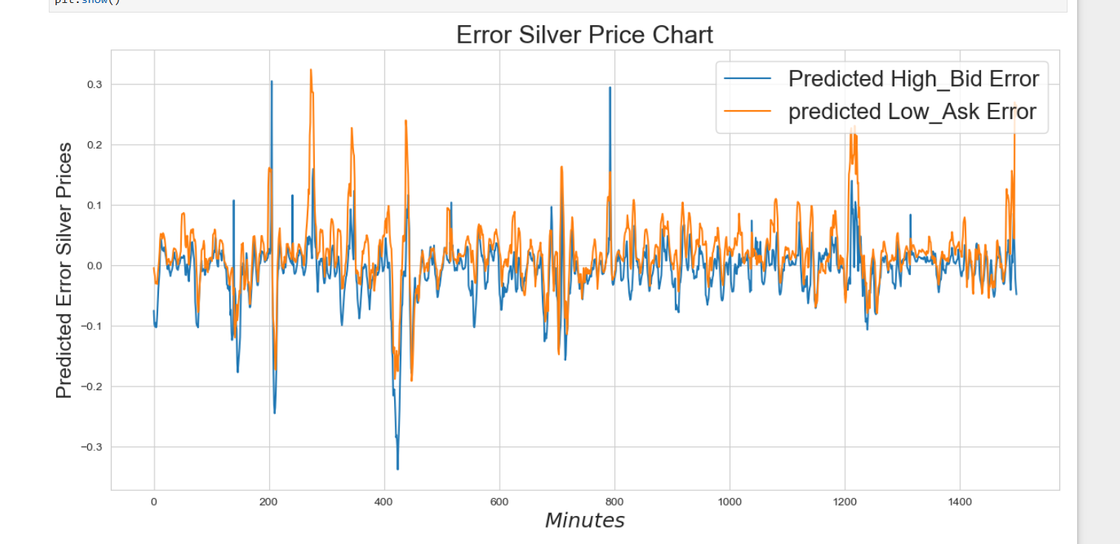
Lab 9
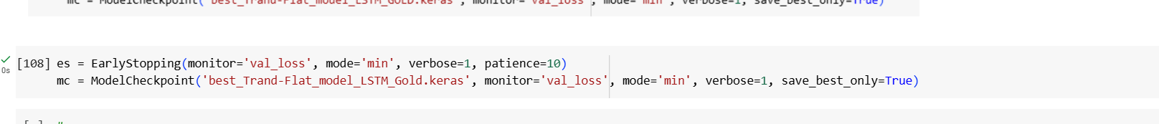
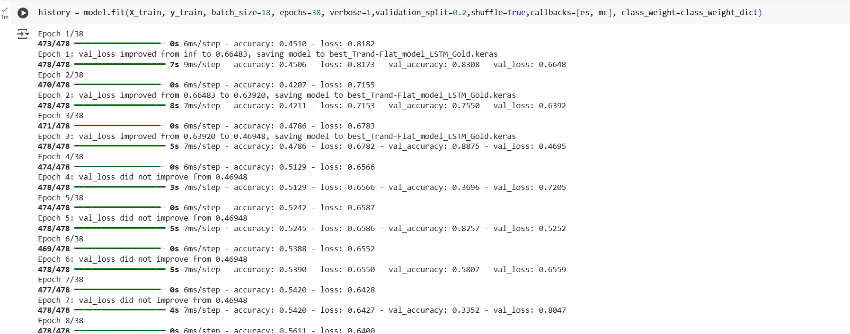
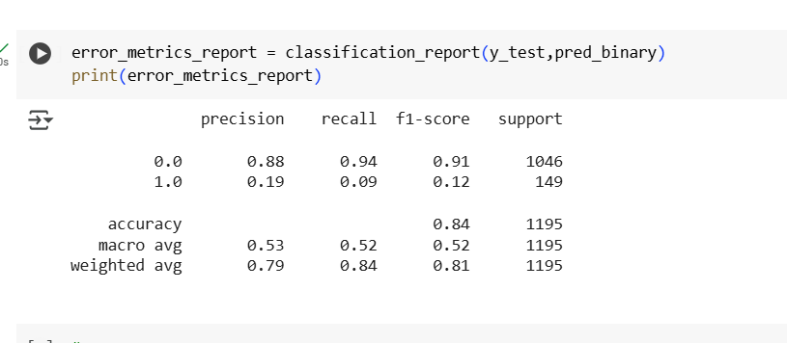
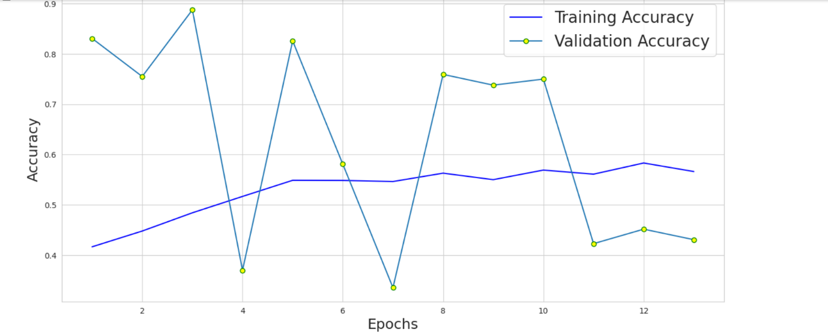
Lab 10
Part-1
Part-2
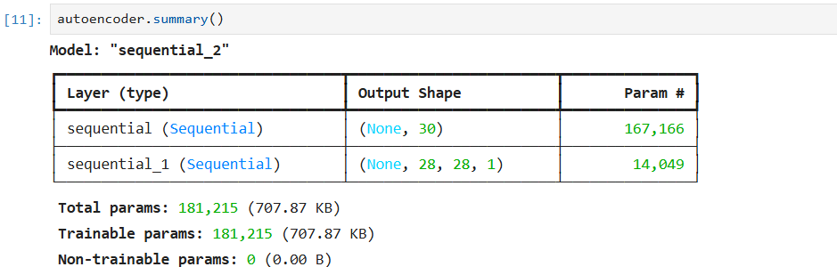
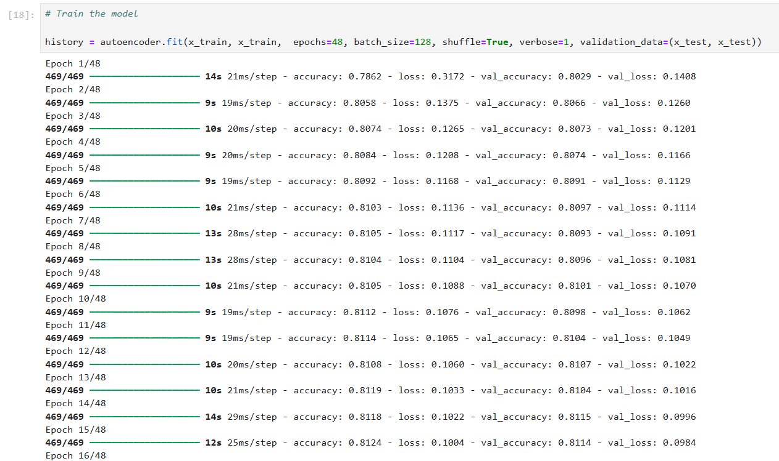
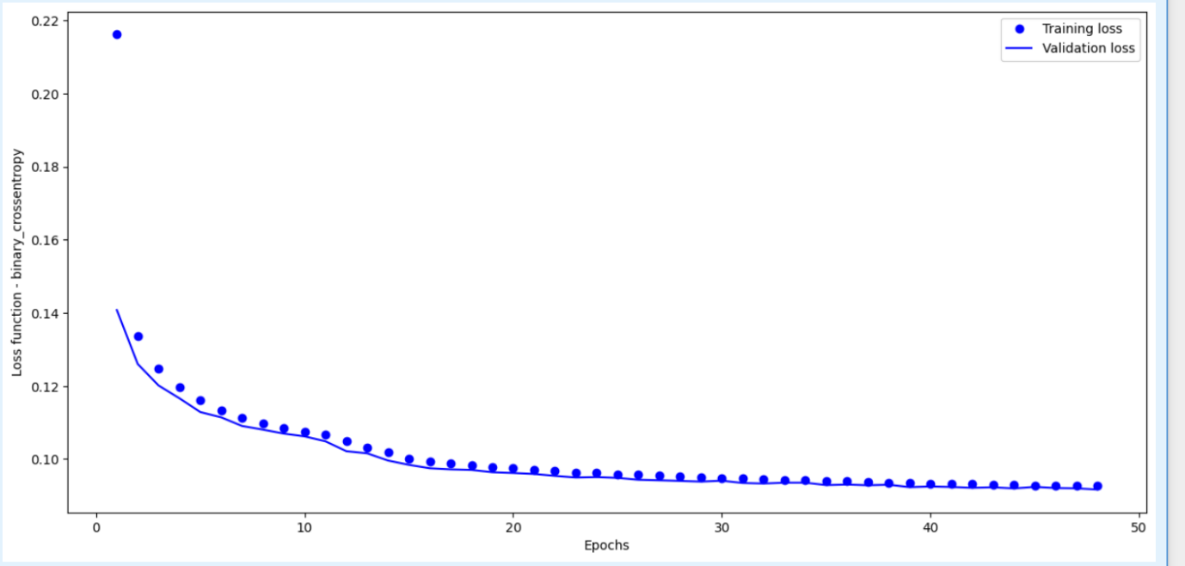
Lab 11

Lab 12

